**Project 2: How to create new instances using amazon machine**

To create a new instance on Amazon Web Services (AWS), you typically use Amazon EC2 (Elastic Compute Cloud). EC2 allows you to create and manage virtual machines (instances) in the cloud. Below is a step-by-step guide on how to launch a new EC2 instance using the

AWS Management Console:

**Rerequisites:**

* You need an **AWS account**. If you don't have one, you can sign up at [AWS](https://aws.amazon.com/).
* Ensure you have **IAM permissions** to create EC2 instances.

Step 1:We have to create VPC(virtual private cloud)

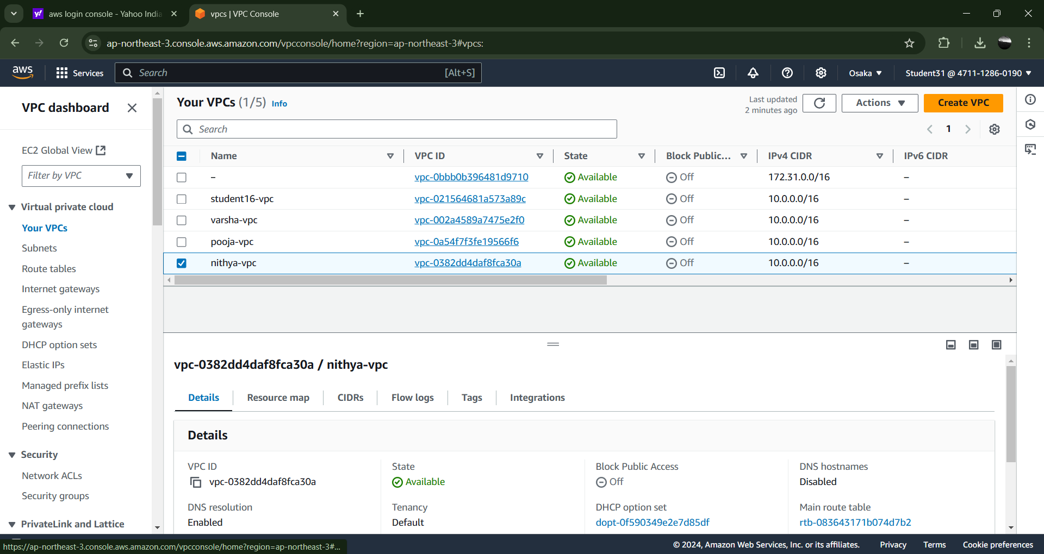

Step 2:

Next creating the internet gateway for the purpose of to make communication between the vpc and public network

After creating the igw then we have to connect to the vpc

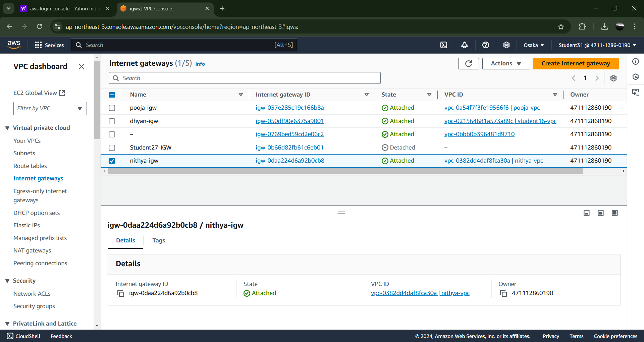

Step 3: After ,we are creating the route table for the purpose of direct network traffic based on the destination IP address then attach to the igw.

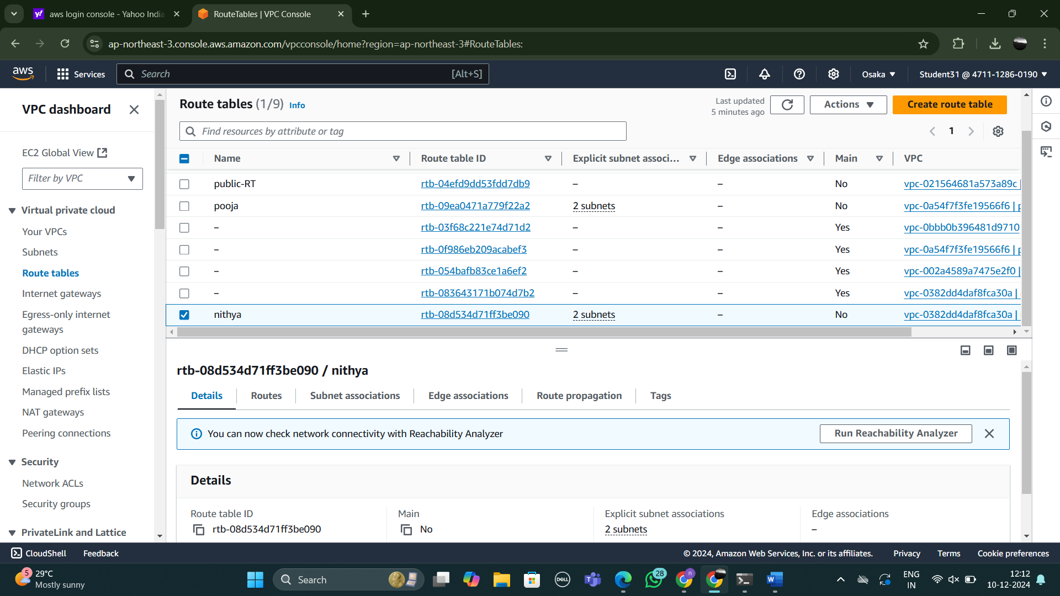

Step 4:Then we are creating the two subnets and then we attach it to the route table

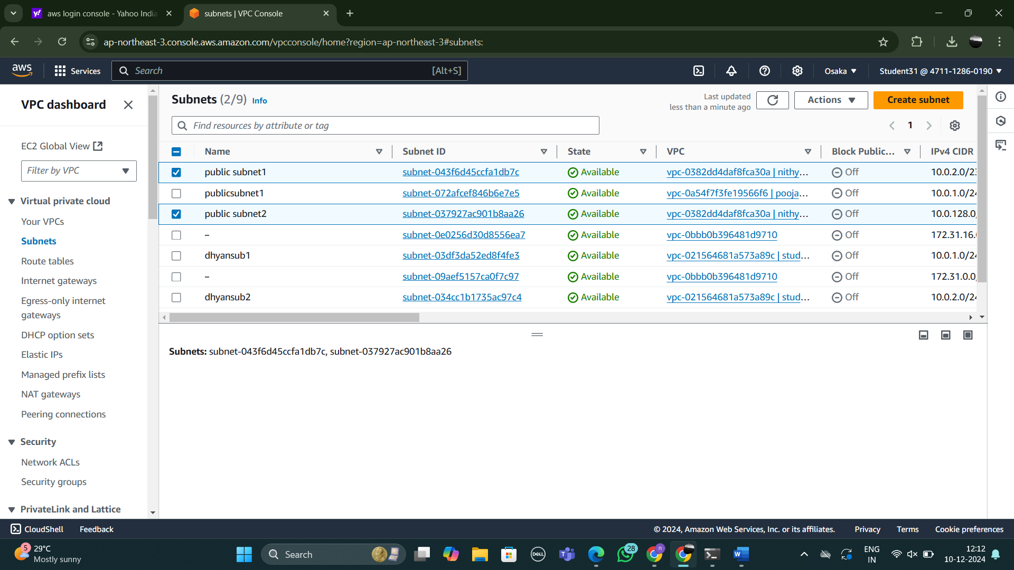

Step5:first we have to create the instance named nithya

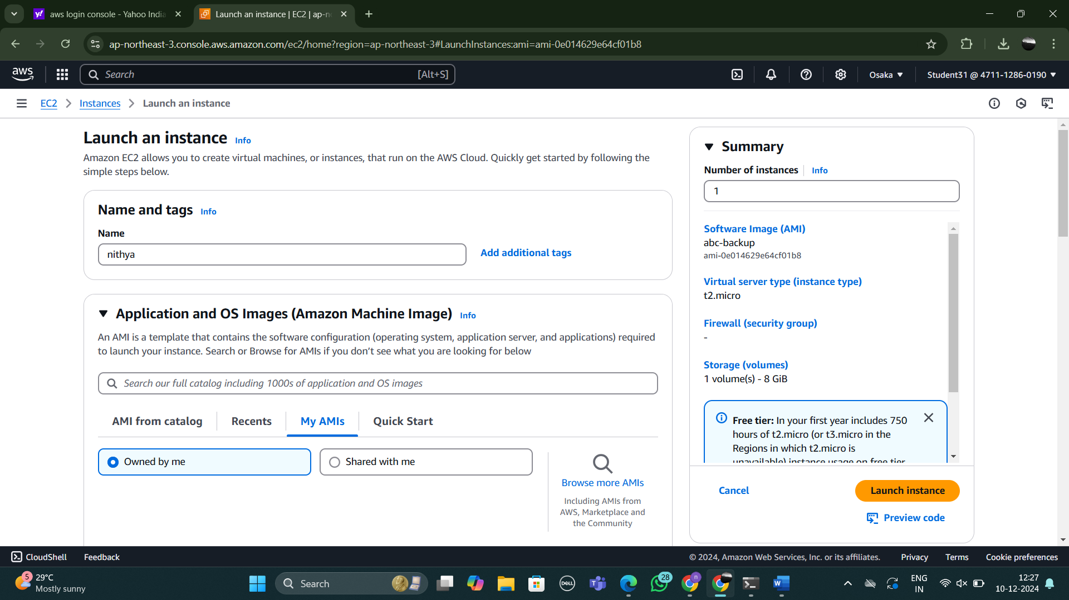

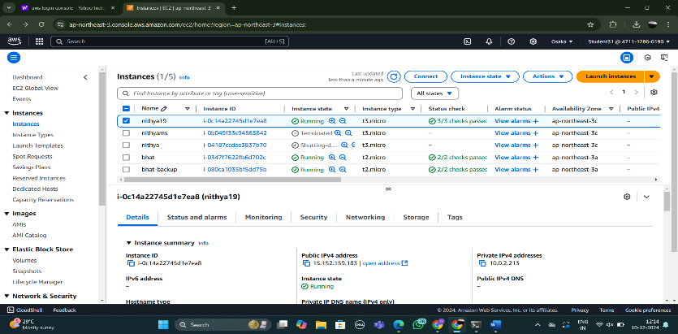

Step 6:select the instances then we have to go to the action button click on that then we have to select the image and template click on that then create image with the name abc-backup create change with some functions then launch AMI instance

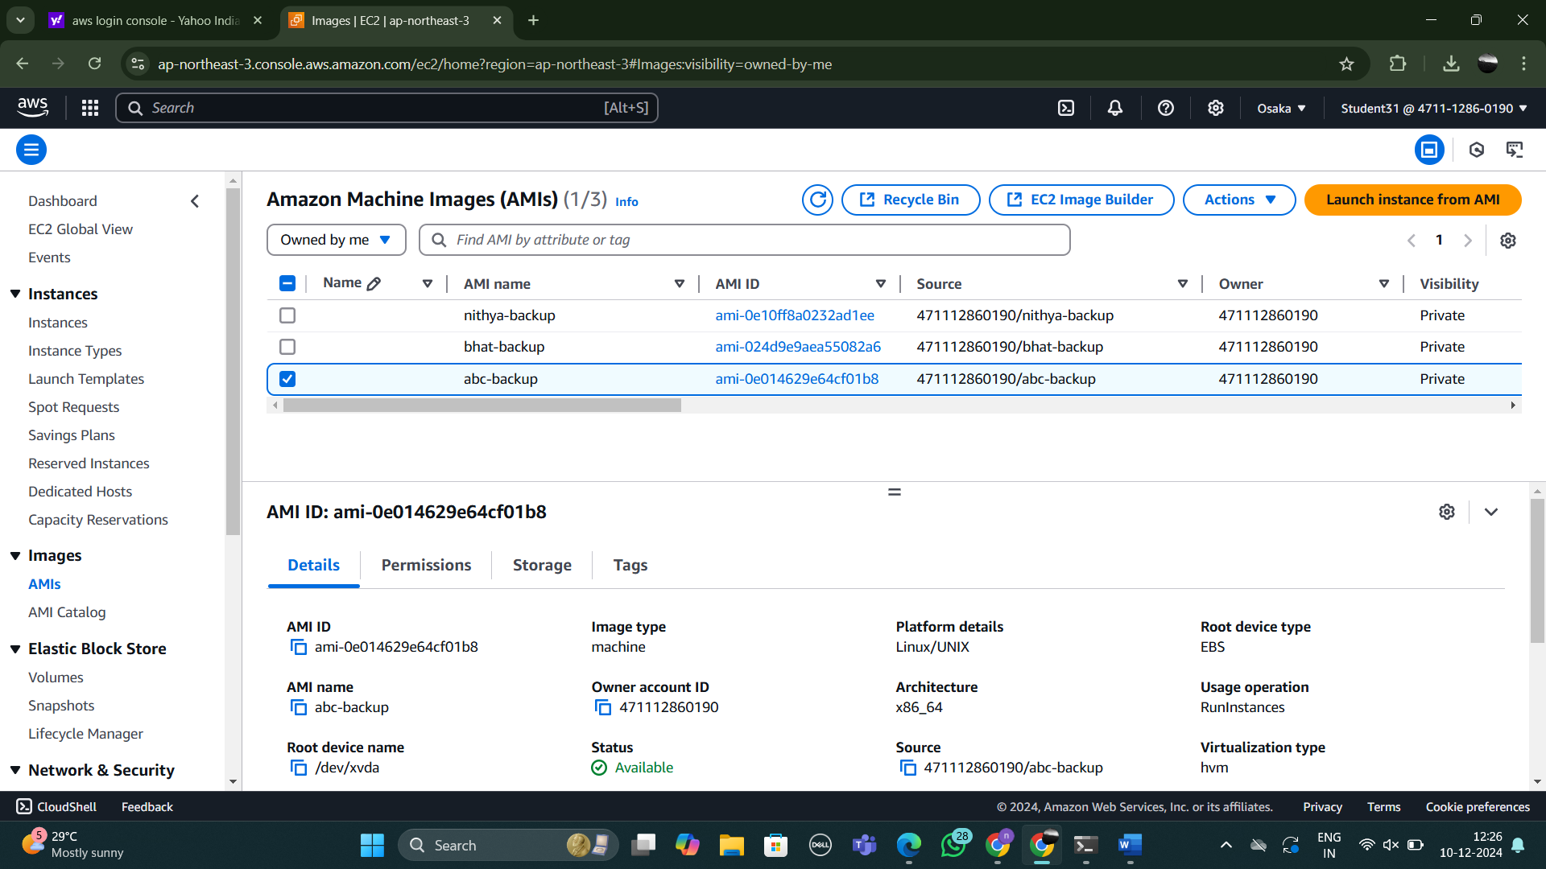

Step 7:then we have to copy the ip address then browse it then we finally get the output.

